HAS Assessment Portal Parameters

Participant will log on to the CLIENT System and click on the HAS URL (provided by HAS System) for taking the HAS assessments.

CLIENT System will post the following parameters to the HAS System

HTTP POST Parameter Name | Required / Optional | Field Length | Comments
UserID | Required | 50 | HAS Generated User ID
Password | Required | 50 | HAS Generated Password
UniqueID | Required | 50 | Client Generated Unique Participant ID
LastName | Required | 50 | String / Text
MiddleName | Optional | 50 | String / Text
FirstName | Required | 50 | String / Text
Age | Optional | Integer | Numeric
Email | Optional | 50 | Varchar (50) Proper email formatting
GenderID | Optional | 6 | See Fixed Values below
Race | Optional | 50 | See Fixed Values below
LanguageID | Required | 2 | Two character Language Code. For Example: en, fr, es.... (see below)
DirectAssessmentID | Required | 10 | "HPI" ; “HDS” ; “MVPI” or “MATR” - Only one assessment ID will be sent.  - If this parameter is sent then MENU page will not be displayed. Participant will start the requested assessment directly. Once assessment is completed, the Participant is redirect back o the Return URL  - If this parameter is NOT sent then  - If MenuPageRequired is set to YES, then all assigned assessments will be displayed in Menu. Participant will click on each assessment link on the Menu page to complete all the assessments. Once all assessments are completed the Participant will be redirected back to the ReturnURL  - If MenuPageRequired is set to NO, then Participant will start the assessment directly, starting with First Assessment assigned. Participant will go through all the assessments assigned, without coming to menu page. Once all assessments are completed the Participant will be redirected back to the ReturnURL.
MenuPageRequired | Optional | 3 | “YES” or “NO". Default is "NO"  This parameter controls if the Menu Page will be displayed to the participant or not.
ReasonforTakingAssessment | Optional |  | See Fixed Values below
JobLevel | Optional |  | See Fixed Values below
JobCategory | Optional |  | See Fixed Values below
HomeCountry | Optional |  | See Fixed Values below
CurrentCountry | Optional |  | See Fixed Values below
YearsinCurrentCountry | Optional | 3 | Numeric
Industry | Optional |  | See Fixed Values below
DisplayInformedConsent | Required | 3 | “YES” or “NO". Default is "YES"
DisplayParticipantInformationLinkOnMenu | Optional | 3 | “YES” or “NO". Default is "NO" If Menu Page is not activated then this is not applicable.
ReturnURL | Optional | 200 | CLIENT System URL where the participant will be redirected after the HAS Assessment is completed  CLIENT System may append a query string token to the end of Return URL, which CLIENT System can use to record, which Participant is Returned Back from HAS System
DisplayLanguageSelectionPage | Optional |  | Default is “Yes”, No will turn off the option for participants to selection an assessment language – default language will be presented if “No”
The ReturnURL can have the following parameters after their URL, and HAS Portal will populate this parameter and return them to the Customer URL : CandID, HASUserID, AssessmentStatus and AssessmentID

These parameters are optional.

To get Candidate ID/Unique ID back, use tag CandID=CandID
and/or
To get HAS User ID assigned to this participant, use tag HASUserID=HASUserID
and/or
To get the Participant Assessment Status, use tag AssessmentStatus=AssessmentStatus
Status value will be COMPLETED, INCOMPLETE, PENDING, ERROR
and/or
To get the Participant Assessment ID, use tag AssessmentID= AssessmentID

Each Query String tag needs to be separated by ampersand sign (&)

Sample Return URL:
http://www.hoganassessments.com/newsletter?CandID=CandID&HASUserID=HASUserID&AssessmentStatus=AssessmentStatus
Result of Sample Return URL: http://www.hoganassessments.com/newsletter?CandID=122345&HASUserID=UH008641&AssessmentStatus=Completed

Note: The text in RED can be replaced with Customer URL

Fixed Value Parameters

Gender ID & Details

Gender ID | Description
1 | Male
2 | Female
9 | Not Specified

Race ID & Details

Ethnicity Code | Ethnicity Name
0 | Two or More Races
1 | Black or African American
2 | Hispanic or Latino
3 | Asian
4 | American Indian or Alaska Native
5 | White
6 | Not Indicated
7 | Declined
8 | Native Hawaiian or Pacific Islander
9 | Others

Job Level
Job Level:
- Executive
- Middle Management
- Entry-level Supervisor
- Individual Contributor

Job Category:
- Management and Executive
- Professionals
- Technicians and Specialists
- Operations and Trades
- Sales
- Customer Support
- Administrative and Clerical
- Service and Support
- Military
- Student

Assessment Purpose
Assessment Purpose:
- Applying for a job
- Part of my current job
- Other

Home Country
Home Country/Current Country:
- Afghanistan
- Albania
- Algeria
- Andorra
- Angola
- Antigua and Barbuda
- Argentina
- Armenia
- Australia
- Austria
- Azerbaijan
- Bahamas
- Bahrain
- Bangladesh
- Barbados
- Belarus
- Belgium
- Belize
- Benin
- Bhutan
- Bolivia
- Bosnia and Herzegovina
- Botswana
- Brazil
- Brunei
- Bulgaria
- Burkina Faso
- Burma
- Burundi
- Cambodia
- Cameroon
- Canada
- Cape Verde
- Central African Republic
- Chad
- Chile
- China
- Colombia
- Comoros
- Costa Rica
- Croatia
- Cuba
- Cyprus
- Czech Republic
- Democratic Republic of the Congo
- Denmark
- Djibouti
- Dominica
- Dominican Republic
- East Timor
- Ecuador
- Egypt
- El Salvador
- Equatorial Guinea
- Eritrea
- Estonia
- Ethiopia
- Fiji
- Finland
- France
- Gabon
- Gambia
- Georgia
- Germany
- Ghana
- Greece
- Grenada
- Guatemala
- Guinea
- Guinea-Bissau
- Guyana
- Haiti
- Honduras
- Hong Kong
- Hungary
- Iceland
- India
- Indonesia
- Iran
- Iraq
- Ireland
- Israel
- Italy
- Ivory Coast
- Jamaica
- Japan
- Jordan
- Kazakhstan
- Kenya
- Kiribati
- Kosovo
- Kuwait
- Kyrgyzstan
- Laos
- Latvia
- Lebanon
- Lesotho
- Liberia
- Libya
- Liechtenstein
- Lithuania
- Luxembourg
- Macedonia
- Madagascar
- Malawi
- Maldives
- Mali
- Malaysia
- Malta
- Marshall Islands
- Mauritania
- Mauritius
- Mexico
- Moldova
- Monaco
- Mongolia
- Montenegro
- Morocco
- Mozambique
- Namibia
- Nauru
- Nepal
- Netherlands
- New Zealand
- Nicaragua
- Niger
- Nigeria
- North Korea
- Norway
- Oman
- Pakistan
- Palau
- Palestine
- Panama
- Papua New Guinea
- Paraguay
- Peru
- Philippines
- Poland
- Portugal
- Qatar
- Republic of the Congo
- Romania
- Russia
- Rwanda
- Saint Kitts and Nevis
- Saint Lucia
- Saint Vincent and the Grenadines
- Samoa
- San Marino
- Sao Tome and Principe
- Saudi Arabia
- Senegal
- Serbia
- Seychelles
- Sierra Leone
- Singapore
- Slovakia
- Slovenia
- Solomon Islands
- Somalia
- South Africa
- South Korea
- South Sudan
- Spain
- Sri Lanka
- Sudan
- Suriname
- Swaziland
- Sweden
- Switzerland
- Syria
- Taiwan
- Tajikistan
- Tanzania
- Thailand
- Togo
- Tonga
- Trinidad and Tobago
- Tunisia
- Turkey
- Turkmenistan
- Tuvalu
- Uganda
- Ukraine
- United Arab Emirates
- United Kingdom
- United States
- Uruguay
- Uzbekistan
- Vanuatu
- Venezuela
- Vietnam
- Yemen
- Zambia
- Zimbabwe

Current Country

Years in Current Country
Years in Current Country:
Only provide if Home & Current country are different = Numeric Entry

Industry
Industry:
- Advertising and Marketing
- Banking and Financial Services
- Business Support Services
- Construction
- Education
- Energy, Utilities, and Telecommunications
- Entertainment and Media
- Food and Beverage
- Government
- Healthcare
- Industrial Metals and Mining
- Information Technology
- Law Enforcement
- Leisure and Hospitality
- Manufacturing
- Pharmaceuticals
- Retail Sales
- Sports and Recreation
- Transportation
- Other

Fixed Value Parameters

Language Codes

Language Code | Language |  | Language Code | Language
ae | South African English |  | in | Indian
au | Australian English |  | is | Icelandic
bg | Bulgarian |  | it | Italian
bi | Bahasa Indonesian |  | ja | Japanese
bm | Bahasa Malaysia |  | ke | Kenya English
bp | Brazilian Portuguese |  | ko | Korean
ca | Castilian Spanish |  | mk | Macedonian
cs | Czech |  | nl | Dutch
cy | Welsh |  | no | Norwegian
da | Danish |  | nz | New Zealand English
eg | English (British) |  | pl | Polish
el | Greek |  | ro | Romanian
en | English (American) |  | ru | Russian
es | Spanish |  | sk | Slovak
et | Estonian |  | sr | Serbian
fc | French (Canadian) |  | sv | Swedish
fi | Finnish |  | th | Thailand
fr | French |  | tr | Turkish
ge | Greek English |  | zc | Chinese (Traditional)
gr | German |  | zh | Chinese (Simplified)
hu | Hungarian

Browser Compatibility
The HAS portal web interface will be compatible to the following browser:

- MS Internet Explorer version 7.0 or above
- Fire Fox 3.0 or above

Participant UAT URL for testing
The following URLs will be used for system testing at UAT environment:

Purpose | URL
Logging and submitting the demographics – directly to HAS Portal | https://www.hoganuat.com/coreparticipant/Participant/Login.aspx

Participant Production URL
The following URLs will be used for production environment:

Purpose | URL
Logging and submitting the demographics – directly to HAS Portal | https://www.assessmentlink.com/coreparticipant/participant/Login.aspx

Web Assessment Process:

1. Participant will login into the CLIENT Portal

- Participant will redirected to the HAS Portal. CLIENT Portal will send all the Demographics and direct login parameters to the HAS Portal

- Participant will be presented with HAS Assessment Menu

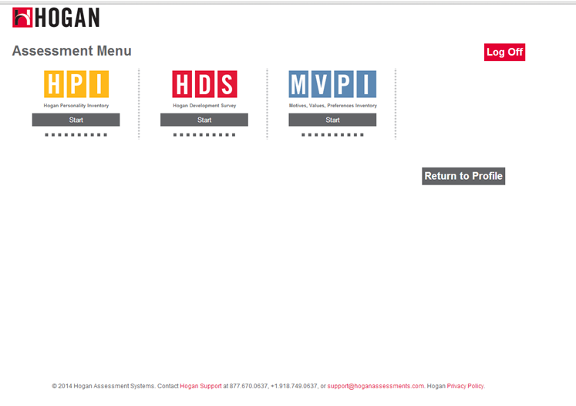

- Participant will start the Assessment Process

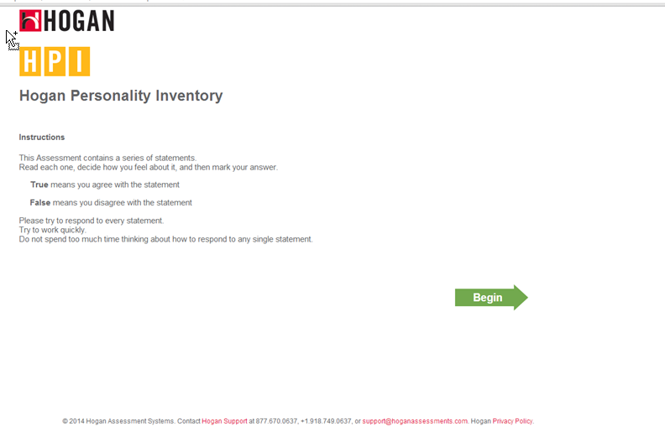

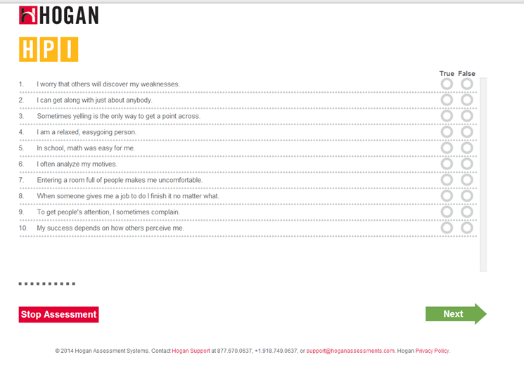

- Participant will complete the Assessment Process

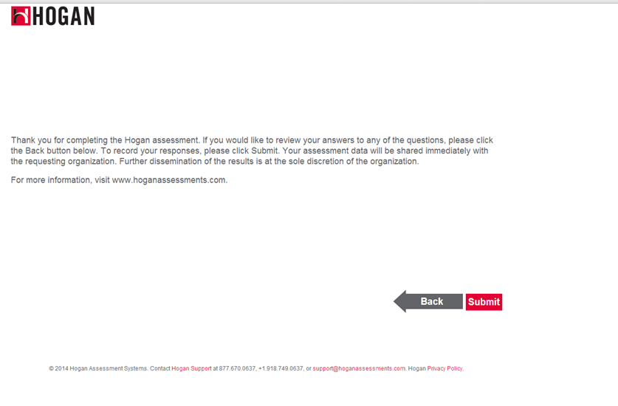

- Participant will be redirected back to the HAS Assessment Menu Page. If the ReturnURL will be provided then Participant will be redirected back to the ReturnURL.

